Question
Module 3 – OOSAD with UML
Chapter 09: Object Interaction

Question 1

What are advantages of distributing system functionality appropriately among classes?

Answer:
- When responsibilities are evenly distributed, each class tends to be simple, self-contained and relatively small. All these increase chances of reusability and ease in maintenance.
- Moreover, an appropriate distribution responsibility makes a system resilient to requirement changes.

Question 2

What are the benefits of keeping all classes relatively small and self-contained?

Answer:
Small self-contained classes are easier to
- develop
- test
- maintain

Question 3

What are interaction and collaboration?

Answer:
- 'The structure of Instances playing roles in behaviour and their relationships is called Collaboration. ‘
- 'An Interaction is defined in the context of Collaboration. It specifies the communication patterns between the roles in the Collaboration. More precisely, it contains a set of partially ordered Messages, each specifying one communication, e.g. what Signal to be sent or what Operation to be invoked, as well as the roles played by the sender and the receiver, respectively.'

Question 4

What is the main difference between a sequence and a collaboration diagram?

Answer:
- Sequence diagrams have a time dimension (normally vertically down the page) while collaboration diagrams do not.
- Collaborations show the links between objects, which are not shown on sequence diagrams.

Question 5

What is an object lifeline?
Answer:
An object lifeline represents the existence of an object during an interaction in a sequence diagram.

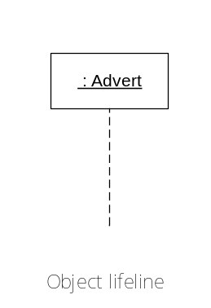

Question 6

What is focus of control in sequence diagram?

Answer:
- Focus of control indicates times during an activation when processing is taking place within that object
- Parts of an activation that are not within the focus of control represent periods when, for example, an operation is waiting for a return from another object
- Focus of control may be shown by shading those parts of the activation rectangle that correspond to active processing by an operation

Object A
Object B
message ()

Question 7

What is a reflexive message?

Answer:
An object can send message to itself. This is known as a reflexive message and is shown by an arrow which starts and finishes at the same object.
Object B
message ()

Question 8

What is a return? What is a return-value?

Answer:
- A return is a return of control to the object that originated the message that began the activation
- A return-value is the value that an operation returns to the object that invoked it.

Question 9

Explain synchronous and asynchronous message.

Answer:

A synchronous message and an asynchronous message differ in behaviour and notation.

Difference in behaviour:
- A synchronous message or procedural call causes the invoking operation to suspend execution until the focus of control has been returned to it
- An asynchronous message does not cause the invoking operation to halt execution while it awaits a return

Difference in notation:
- A synchronous message is shown with a full arrowhead
- An asynchronous message is shown with an open arrowhead

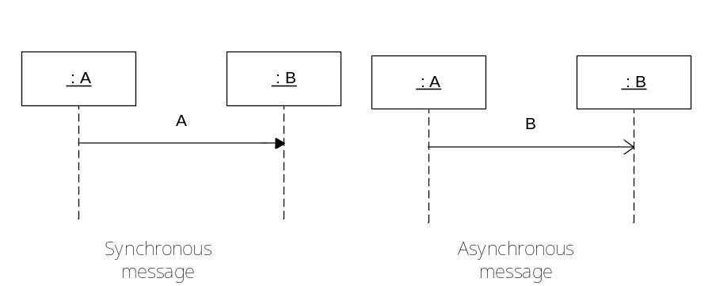

Question 10

What consistency checks should be applied to interaction diagrams?

Answer:
- The allocation of operations to objects must be consistent with the class diagram and the message signature must match that of the operation
- Every sending object must have the object reference for the destination object
- If both sequence and collaboration diagrams are prepared they should be consistent
- Messages on interaction diagrams must be consistent with the statecharts for the participating objects
- Implicit state changes in interaction diagrams must be consistent with those explicitly modelled in statecharts

